The thermoelectric effect is, generally, the conversion from voltage to temperature, and vice-versa. In fact, the thermoelectric effect is an umbrella term for three different phenomenon: the Seebeck effect, the Peltier effect, and the Thomson effect. The first two of these, the Seebeck and Peltier effect, both describe the same process. The reason that this isn’t simply described as a single effect is due to the independent discoveries of this effect by Jean Peltier and Thomas Seebeck. Lord Kelvin was the scientist who discovered the Thomson effect – an extension of the Peltier and Seebeck effect, which we will not investigate in this lab.

The Seebeck effect is the conversion of heat to electricity due to differences of material properties at a junction. This is because electrons and holes are carriers of both charge and heat. The specific properties of a material will dictate the potential difference formed from a temperature gradient. The faster moving particles at the hot end reduce the charge density, and the slower moving particles at the cold end build up charge density. A schematic of this phenomenon is shown in **[Figure 1]**. The relevant material properties that contribute to this effect are grouped into a single coefficient known as the Seebeck coefficient, α. The Peltier effect is just the creation of temperature flow across materials by an external electric potential, shown in **[Figure 2]**. This can be used for refrigeration purposes. The efficiency of these devices have limited their uses to applications such as cooling laser diodes. The maximum efficiency of a thermoelectric device can be found with two values – the Carnot efficiency and the thermoelectric figure of merit. The thermoelectric figure of merit, zT, is a combination of the Seebeck coefficient, electrical resistivity, and thermal conductivity (shown in **[Equation 1]**).The maximum efficiency equation is shown in **[Equation 2]**. A large materials challenge is that of the thermoelectric compatibility factor s, shown in **[Equation 3]**. The materials used in these applications must have appropriate properties for the application, as well as not have differences in thermoelectric compatibility factor greater than a factor of two for maximum efficiency.

Two plots are shown in **[Figures 3 and 4]**, which demonstrate the difference of input and output power. The input power curve, shown in **[Figure 3]**, is integrated with respect to time to give input energy. This is compared to the energy found by integrating the output power curve. The % useful work is the output integral divided by the difference between hot and cold sinks – 2.7%.The ratio of the engine integral over the pump integral results in the % recovered work and gives a strong indicator of the efficiency of our device – 0.29%. This is clearly an awful thermocouple. The large inefficiencies are from the two materials not forming a proper thermocouple, as well as heat lost to the environment. The insulators used helped, as they eliminated heat loss to the surrounding system.

$$zT=\frac{α^{2}T}{pk}$$

**Equation 1**: thermoelectric figure of merit

$$n_{max}=\frac{ΔT}{T_{h}}\frac{\sqrt{1+zT}-1}{\sqrt{1+zT}+1}$$

**Equation 2**: theoretical maximum efficiency

$$s=\frac{\sqrt{1+zT}-1}{αT}$$

**Equation 3**: thermoelectric compatibility factor

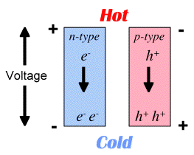

**Figure 1**: Voltage generation from temperature gradient

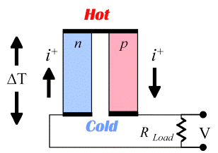

**Figure 2**: Temperature gradient from current

**Figure 3**: Input power

**Figure 4**: Generated power

**References**

http://thermoelectrics.matsci.northwestern.edu/thermoelectrics/